Please select the answer to the below questions (Please delete not appropriate):
(I) Select the category. 1 2 3 4 5 6 7

1) Basic Optical and Physical Properties of Organic/Polymeric Materials
2) Science & Technologies of Organic/Polymeric Optical Materials
3) Polymer Optical Circuits, Devices, and Packaging Technologies
4) Science & Technologies of Nano-particles (including super-critical conditions).
5) Polymer/inorganic Hybrid Materials for Optical Applications.
6) Polymer/inorganic Hybrid Materials for Electronic and Thermal Applications
7) Others (Please specify : )
10th ISAOP & 1st ISSM Joint Symposium
Will Be Held in Tokyo and Sendai in the Summer of 2010

Tadafumi Adschiri^{1,}*, and Shinji Ando²

¹ 1) Institute of Multidisciplinary Research for Advanced Materials, Tohoku University
2-1-1 Katahira, Aoba-ku, Sendai 980-8577, Japan
² Department of Chemistry & Materials Science, Tokyo Institute of Technology,
Ookayama 2-12-1-E4-5, Meguro-ku, Yokyo, 152-8552, Japan

*Tel : +81-22-217-5629, Fax: +81-22-217-5629 , e-mail : ajiri@tagen.tohoku.ac.jp

It is our great pleasure to invite you to the 10th International Symposium on Advanced Organic Photonics (ISAOP-10) and 1st International Symposium on Super-hybrid Materials (ISSM-1) which will be held in Tokyo and Sendai, Japan in Sept 28-Oct 2, 2010, of which the scientific program will concern with all aspects of Functional Organic/Polymeric Materials for Advanced Photonics and Inorganic/Organic Nano-hybrid Materials including Nanoparticle Technology for Optoelectronics, Power Electronics, and Microelectronics, which have potential widespread applications in such diverse areas due to their unique combination of physical and chemical properties. This symposium is organized to bring together scientists and engineers who are interested in such functional materials, to review and assess the current state of knowledge, to provide a forum for exchange and cross-fertilization of ideas, and to define problem areas which need intensified efforts.

Keywords : ISAOP-10, ISSM-1, instruction

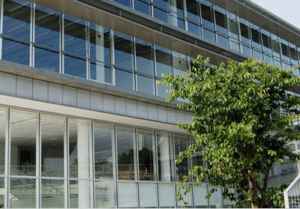 | 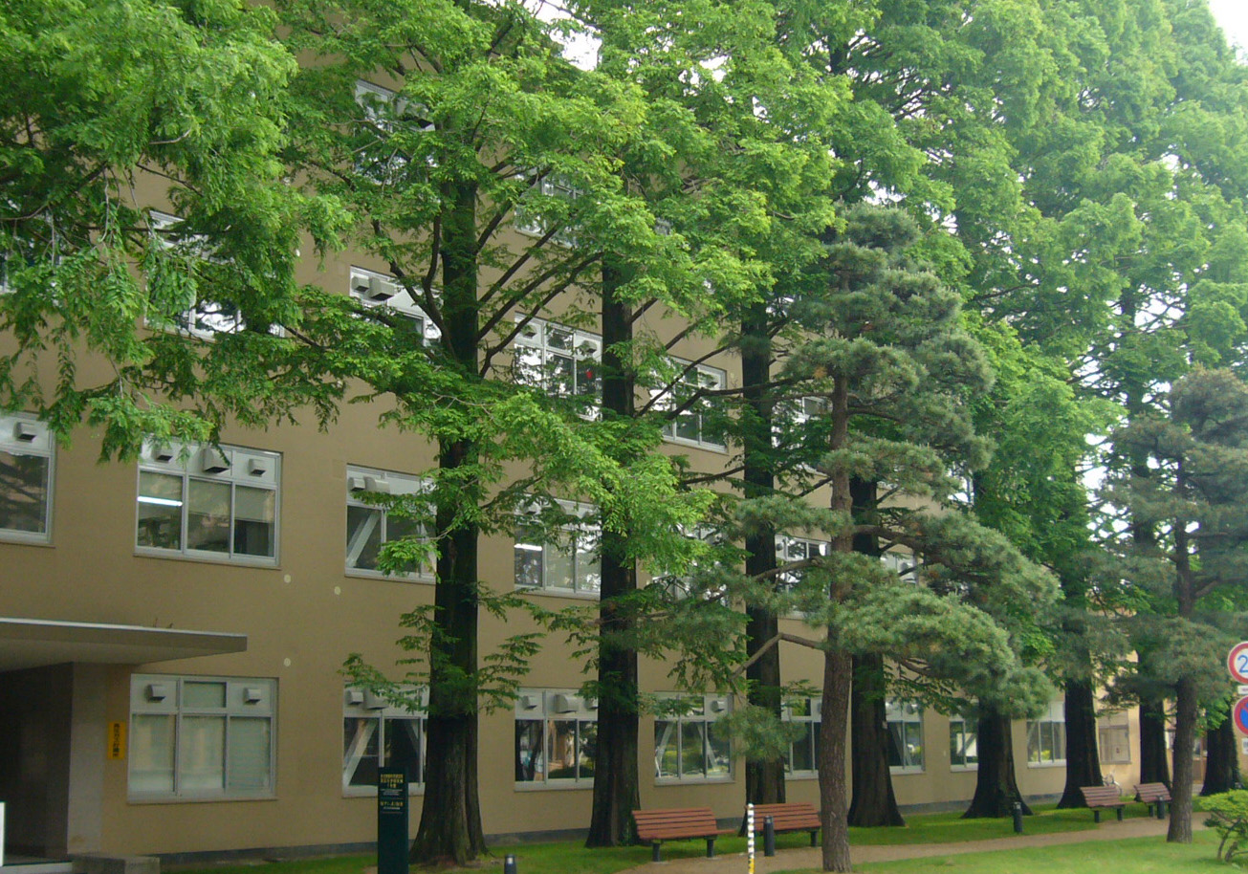
Figure. 1. A view of Kuramae Hall of Tokyo Institute of Technology which is located in front of Ookayama Station (Tokyu Meguro line and Ooimachi line). | Figure 2. A view of one building of Tagen Labs (Institute of Multidisciplinary Research for Advanced Materials) which is located in Katahira campus of Tohoku University (5 min by taxi or 20 min by walking from Sendai station).

References
1. M. Taguchi, S. Takami, T. Naka, T. Adschiri, Crystal Growth & Design, 9, 5297-5303 (2009).
2. J. Wakita, S. Inoue, N. Kawanishi and S. Ando, Macromolecues, 43, 3594-3605 (2010).

